**File IO using python**

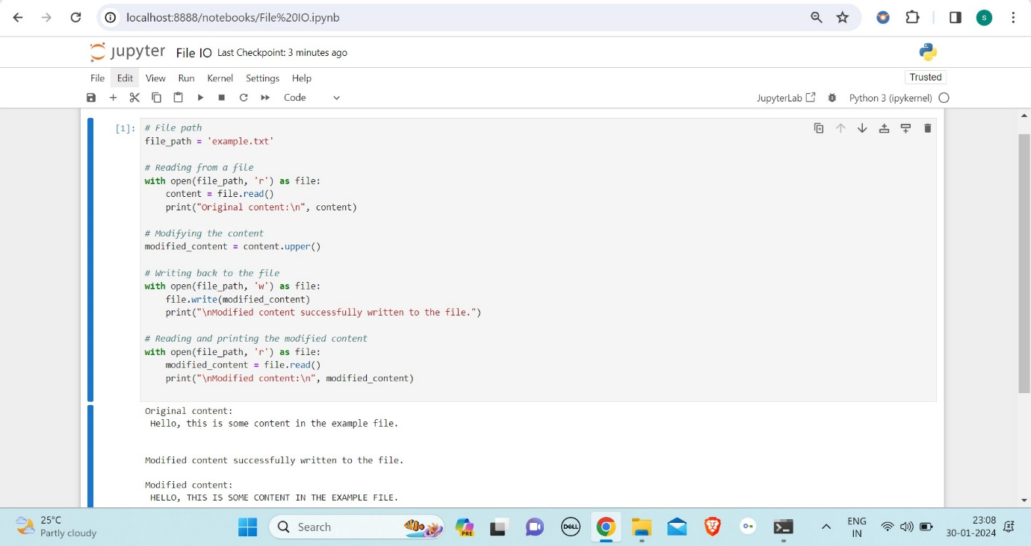

**Read data from CSV file into python list**

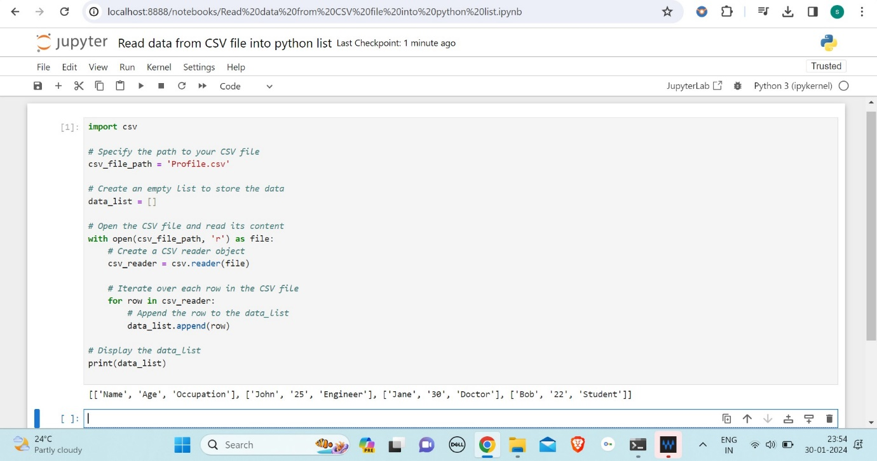

**Processing python lists**

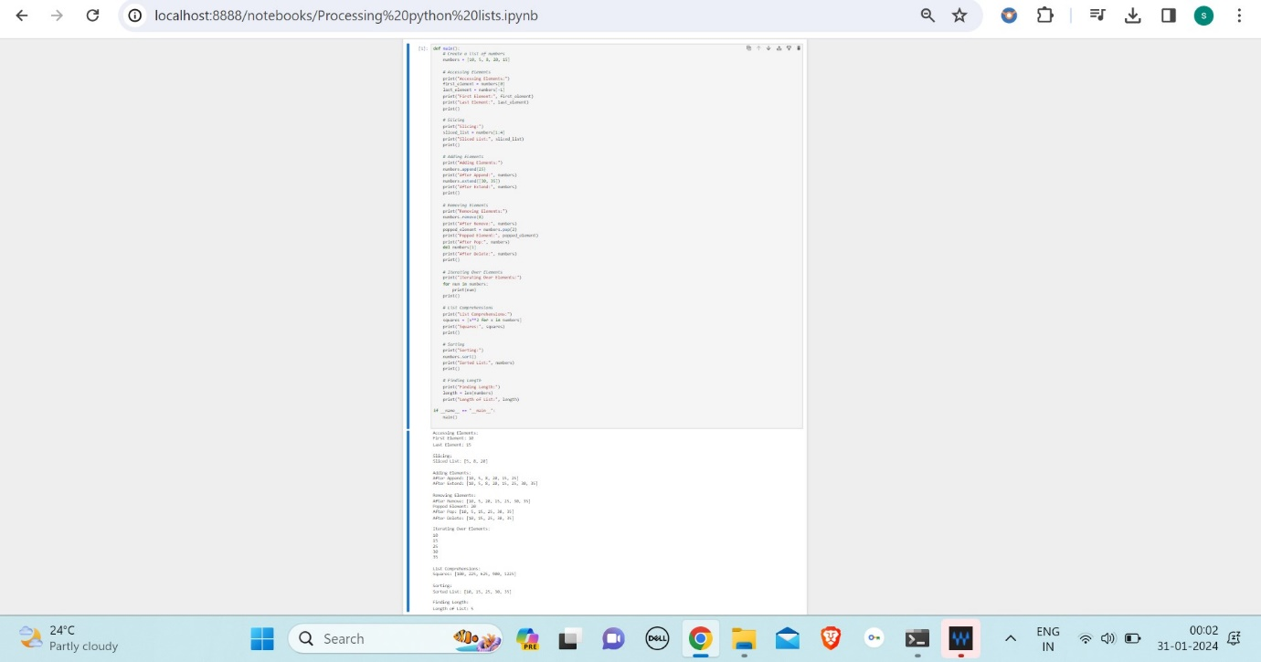

**Lambda functions in python**

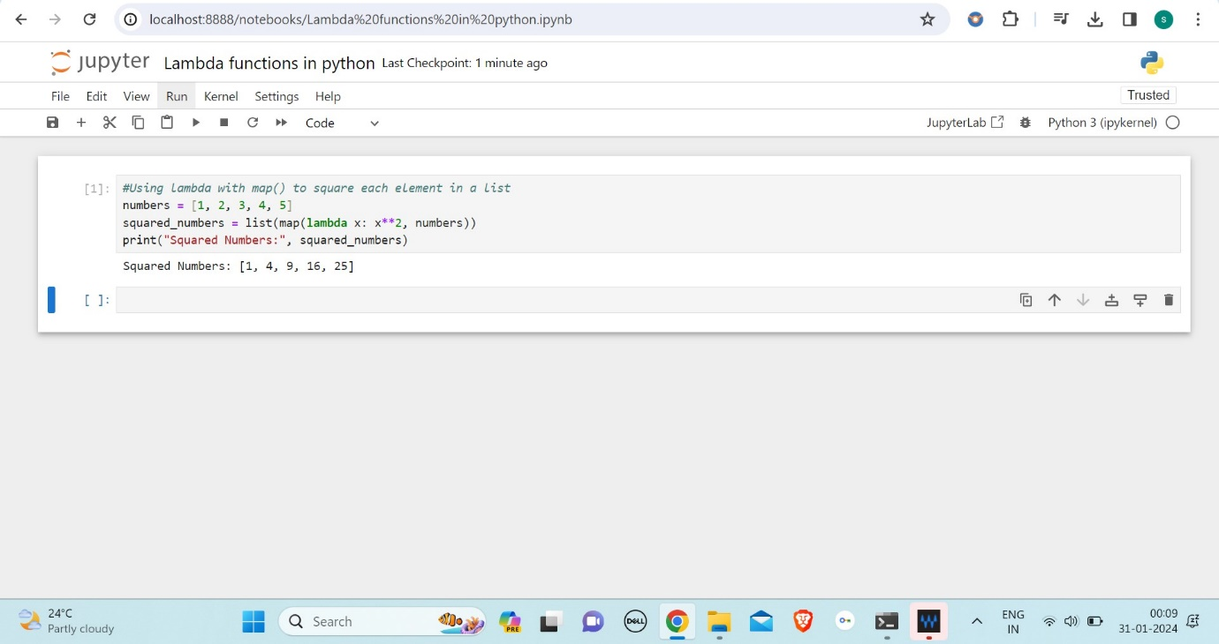

**Filter data in python lists using filter and reduce**

1. **Use of lambda function in python**

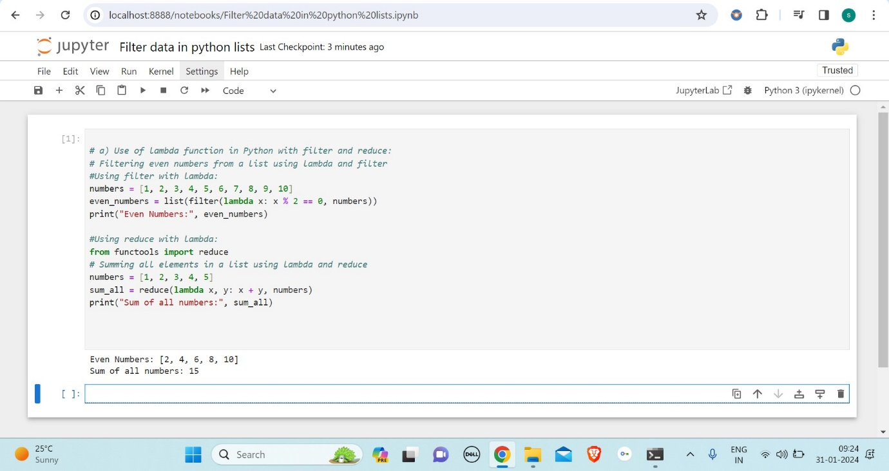

1. **practical uses of python lambda function**

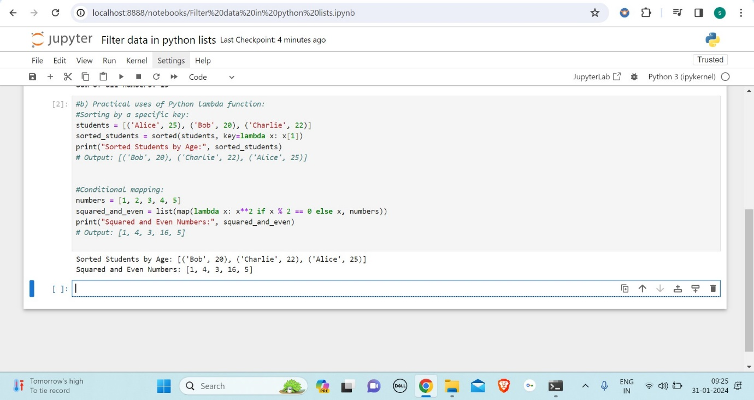

1. **using lambda function with map, filter, reduce**

